1. Create a database called the bakery.
2. Create a table called Customers.
3. Add the following fields with the appropriate properties.

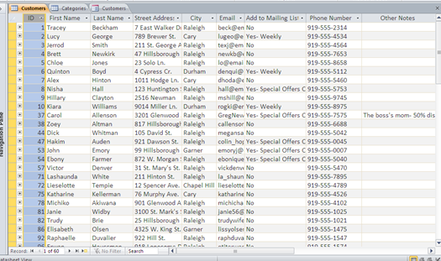

1. Enter a minimum of 10 customer details.
2. Create a data entry form for the customers table.
3. Hide the id filed and label.
4. Insert a combo box to replace the add to mailing list text box.
5. Add the following options to the combo box. “No, Yes -Weekly, Yes-Special occasions only.
6. Add two buttons. The first to refresh the database and the second to close the form.
7. Inset a suitable image to enhance the form.